1. **RFID 卡可用本校教職員證、學生證、悠遊卡或台灣通卡(台中市公車卡)。  
   RFID cards can include the University staff ID, student ID, EasyCard, or Taiwan Pass (Taichung City Bus Card).**
2. **RFID 卡序號查詢可使用 7 樓的 RFID 門禁卡感應器。  
   RFID card serial numbers can be checked using the RFID access card reader on the 7th floor.**

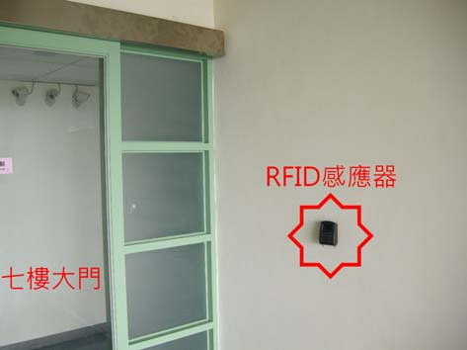

將卡片放在感應器前，即可看到兩組五位數字 (抱歉! 我有馬賽克兩個數字)  
Place the card in front of the reader to see two sets of five-digit numbers (apologies! Two digits have been redacted).

